Tangent and stationary points
EM1 · 15 marks

Question
Let $f(x)=x^{3}−3x^{2}−9x$. The graph below is provided for visualisation only; obtain all numerical values by calculation. Point $P$ on the curve corresponds to $x=0$.
(a) Find $f^{′}(x)$. [2 marks]
(b) Find the equation of the tangent to $y=f(x)$ at $P$. [3 marks]
(c) Find the $x$-values of the stationary points. [3 marks]
(d) Find the coordinates of the stationary points. [2 marks]
(e) Using the first-derivative test, determine whether each stationary point is a relative maximum point or a relative minimum point. [3 marks]
(f) State the intervals on which $f$ is increasing and decreasing. [2 marks]
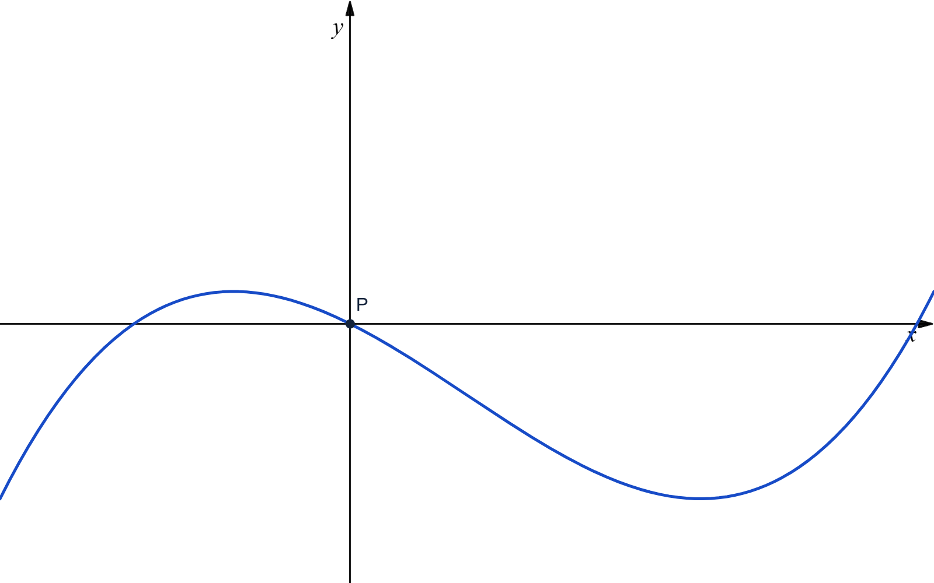
Non-to-scale graph of $y=f(x)$ for visualisation only.

Main solution
Main solution
(a) Differentiate:
$f^{′}(x)=3x^{2}−6x−9.$
(b) Since $P=(0,f(0))=(0,0)$ and
$f^{′}(0)=−9,$
the tangent has gradient $−9$. Hence
$y−0=−9(x−0),$
so the equation of the tangent is
$y=−9x.$
(c) At a stationary point, $f^{′}(x)=0$:
$3x^{2}−6x−9=0,$
$3(x^{2}−2x−3)=0,$
$3(x−3)(x+1)=0.$
Thus, the stationary-point $x$-values are
$x=−1 and x=3.$
(d) Evaluate $f$ at these values:
$f(−1)=(−1)^{3}−3(−1)^{2}−9(−1)=5,$
$f(3)=3^{3}−3(3)^{2}−9(3)=−27.$
The stationary points are $(−1,5)$ and $(3,−27)$.
(e) Using $f^{′}(x)=3(x−3)(x+1)$, its signs are:
$\begin{matrix}x & (−∞,−1) & (−1,3) & (3,∞) \\ f^{′}(x) & + & − & +\end{matrix}$
At $x=−1$, $f^{′}(x)$ changes from positive to negative, so $(−1,5)$ is a relative maximum point.
At $x=3$, $f^{′}(x)$ changes from negative to positive, so $(3,−27)$ is a relative minimum point.
(f) Since $f^{′}(x)>0$ on $(−∞,−1)$ and $(3,∞)$, $f$ is increasing on
$(−∞,−1)∪(3,∞).$
Since $f^{′}(x)<0$ on $(−1,3)$, $f$ is decreasing on
$(−1,3).$

Proposed marking allocation
(a): Obtains $f^{′}(x)=3x^{2}−6x−9$. [2 marks]
(b): Determines $P=(0,0)$ and the tangent gradient $f^{′}(0)=−9$. [2 marks]
(b): Forms the tangent equation $y=−9x$. [1 marks]
(c): Sets $f^{′}(x)=0$ and factorises or otherwise solves the resulting quadratic correctly. [2 marks]
(c): States $x=−1$ and $x=3$. [1 marks]
(d): Calculates the stationary-point coordinates as $(−1,5)$ and $(3,−27)$. [2 marks]
(e): Establishes that $f^{′}(x)$ has signs $+,−,+$ on the three intervals separated by $−1$ and $3$. [2 marks]
(e): Uses the sign changes to identify $(−1,5)$ as a relative maximum and $(3,−27)$ as a relative minimum. [1 marks]
(f): States that $f$ is increasing on $(−∞,−1)∪(3,∞)$. [1 marks]
(f): States that $f$ is decreasing on $(−1,3)$. [1 marks]

Reference questions
EXAM AY2025/2026 S2 · A4
EXAM AY2024/2025 S2 · B6(b)
EXAM AY2025/2026 S1 · B6(a)
EXAM AY2025/2026 S1 · A5

